Day80 - Task38 - Kubernetes(Part-02)

1. Create a Simple Pod Using YAML Task: Write a YAML file to create a Pod named firstpod with an nginx container. Verify the Pod creation using kubectl get pods and check the logs of the container using kubectl logs firstpod.

Step 1. Create the YAML file
- On Kubernetes master/control-plane node, create a file: vi firstpod.yaml
- Add this YAML:
apiVersion: v1
kind: Pod
metadata:
name: firstpod
spec:
containers:
- name: nginx
image: nginx:latest
- Save and exit: Esc, :wq, Enter
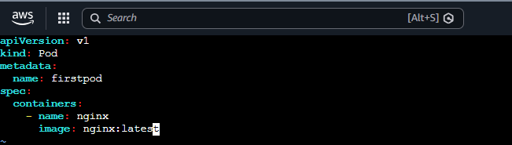

Step 2. Create the Pod
- Run: kubectl apply -f firstpod.yaml
- You should see: pod/firstpod created
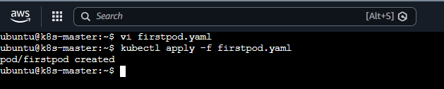

Step 3. Verify the Pod
- Run: kubectl get pods
- Initially you may see:

NAME | READY | STATUS | RESTARTS | AGE
firstpod | 0/1 | ContainerCreating | 0 | 5s
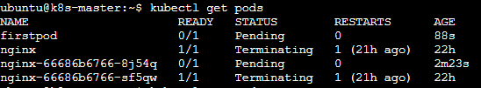
- Wait a few seconds and run again: kubectl get pods
- You should eventually see:

NAME | READY | STATUS | RESTARTS | AGE
firstpod | 1/1 | Running | 0 | 20s
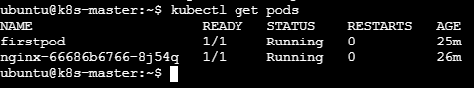

- For more details: kubectl get pods -o wide

Step 4. Check the Nginx container logs
- Run: kubectl logs firstpod
- You should see Nginx-related startup/access log output. If there have been no requests yet, the output may be very small or even empty depending on the Nginx image/version.
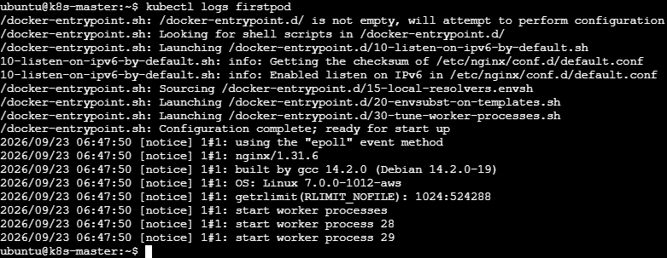

2. Set Environment Variables in a Pod Task: Modify the YAML file to include environment variables myname: sabair and City: Hyderabad. Deploy the Pod and use kubectl exec <pod_name> -- env to check if the environment variables are set properly.
Step 1: Edit the YAML file
- vi firstpod.yaml
- Save and Exit

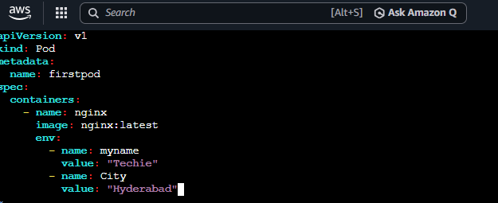

Step 2: Deploy the Pod
- Because the existing firstpod cannot simply be modified for this change, delete it first: kubectl delete pod firstpod
- Then create it again: kubectl apply -f firstpod.yaml
- You should get: pod/firstpod created
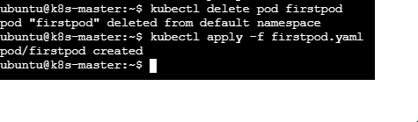
Step 3. Check the Pod
- kubectl get pods
- Wait until you see:
NAME | READY | STATUS | RESTARTS | AGE
firstpod | 1/1 | Running | 0 | …

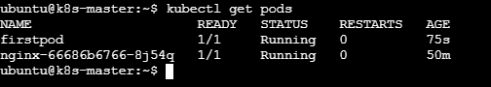

Step 4. Check the environment variables
- Run exactly what the task asks: kubectl exec firstpod -- env
- You should find: myname=Techie, City=Hyderabad
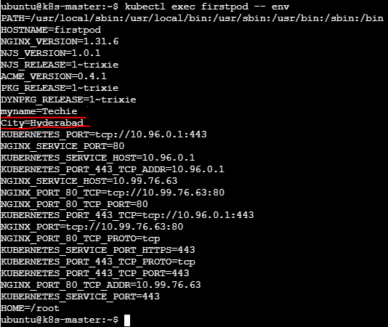

Step 5. Check only these two variables
- For a cleaner result: kubectl exec firstpod -- env | grep -E 'myname|City'
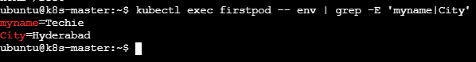

3. Deploy a Pod with Commands (Args) in YAML Task: Modify the YAML file to add args that instruct the container to sleep for 50 seconds. Deploy the Pod and use kubectl describe pod to verify the args are correctly passed to the container.

Step 1. Edit the YAML file
- vi firstpod.yaml
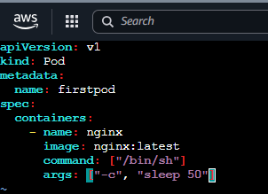
The container will run for approximately 50 seconds, then exit.

Step 2. Delete the old Pod
As we are modifying the Pod configuration, delete the existing Pod first: kubectl delete pod firstpod
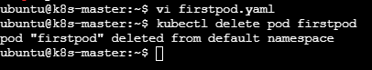

Step 3. Deploy the modified Pod
- kubectl apply -f firstpod.yaml
- Expected: pod/firstpod created
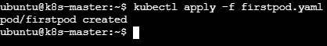
Step 4. Check the Pod
- Immediately run: kubectl get pods
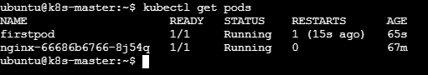
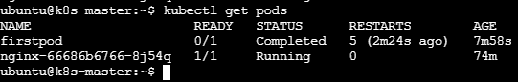
Step 5. Verify the args using kubectl describe
- This is the main requirement of your task: kubectl describe pod firstpod
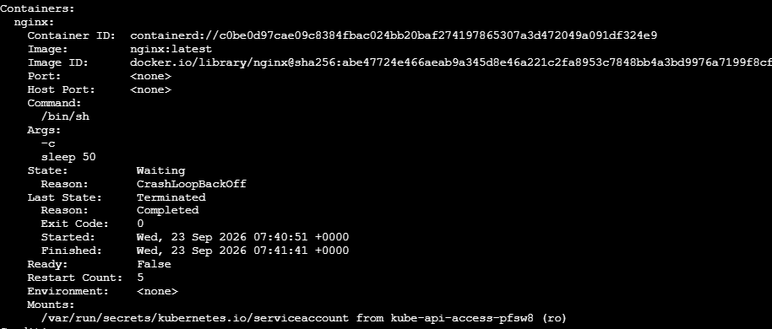

4.Create a Pod with Two Containers Task: Create a YAML file to define a Pod with two nginx containers inside. Use kubectl exec to access both containers and verify that both containers can communicate through the same network (e.g., using telnet between them).

Step 1. Create the YAML file
- vi twocontainers.yaml
- Save and exit.
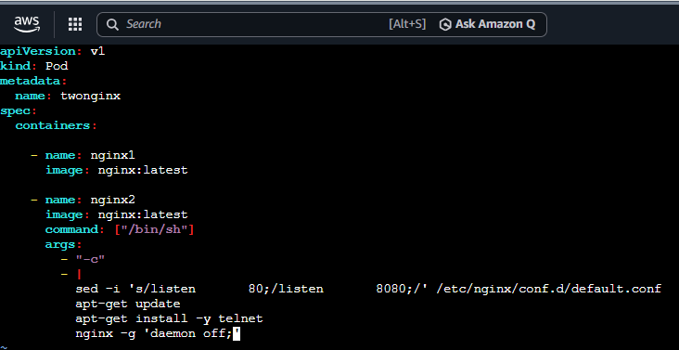

Step 2. Create the Pod
- If you already have a Pod named firstpod, that is a different Pod, so it can remain.
- Run: kubectl apply -f twocontainers.yaml
- Expected: pod/twonginx create
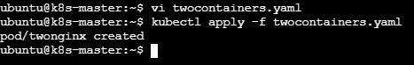
Step 3. Check the Pod
- kubectl get pods
- You should eventually see:
NAME | READY | STATUS | RESTARTS | AGE
firstpod | 2/2 | Running | 0 | …

- The important part is: 2/2
- This means both containers are running.
- If it shows 1/2, wait a little longer because nginx2 has to install telnet.
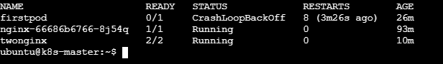

Step 4. Access the first container
- Run:kubectl exec -it twonginx -c nginx1 -- /bin/sh
- You should get a shell such as: #

- You are now inside nginx1.
- Exit: exit
Step 5. Access the second container
- Run: kubectl exec -it twonginx -c nginx2 -- /bin/sh
- You are now inside nginx2.
- Exit: Exit
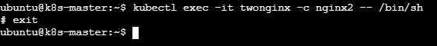

Step 6. Check that both containers have the same Pod IP
- Run: kubectl get pod twonginx -o wide
- Example:
NAME | READY | STATUS | RESTARTS | AGE
firstpod | 2/2 | Running | 10.244.1.5 | worker1

- Both containers use: 10.244.1.5
- because they belong to the same Pod.

Step 7. Test communication between the nodes
- Run on the Kubernetes master: nc -zv <WORKER-IP> 179
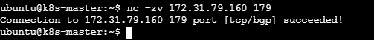

5. Set Up an Init Container in a Pod Task: Modify the YAML to include an init container that sleeps for 30 seconds before the main containers start. Verify the init container's execution using kubectl describe pod and check the logs to confirm its completion.

Step 1. Create the YAML file
- Create a file: vi init-container-pod.yaml
- Save and exit.
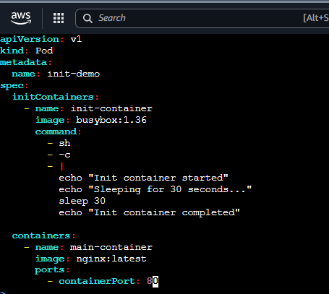

Step 2. Create the Pod
- On Kubernetes master
- Run: kubectl apply -f init-container-pod.yaml
- You should see: pod/init-demo created
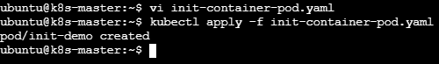

Step 3. Immediately check the Pod
- Run: kubectl get pod init-demo
- During the 30 seconds, you may see:
NAME | READY | STATUS | RESTARTS | AGE
init-demo | 0/1 | Init:0/1 | 0 | 5s

- This means: Init:0/1
- The init container is still running.
- After approximately 30 seconds, run: kubectl get pod init-demo
- You should see:
NAME | READY | STATUS | RESTARTS | AGE
init-demo | 1/1 | Running | 0 | 40s

- Now the init container has completed and the nginx container is running.
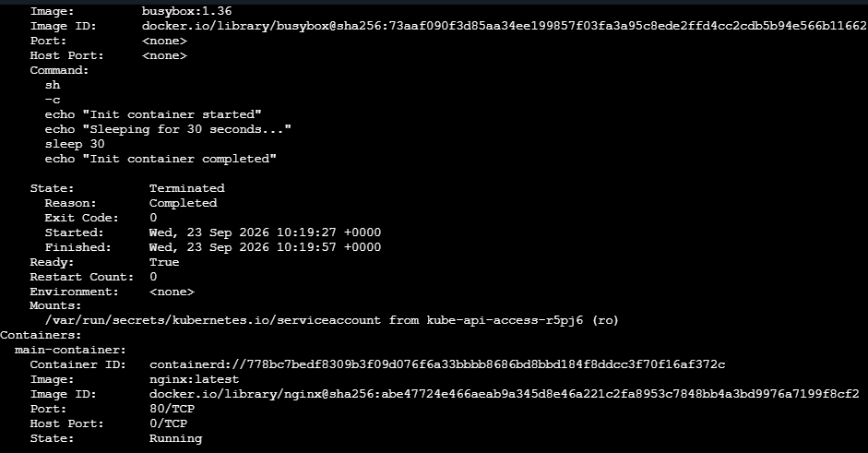

Step 4. Check init container logs
- This is another requirement of your assignment.
- Run: kubectl logs init-demo -c init-container
- You should get: Init container started
- Sleeping for 30 seconds...
- Init container completed
- This confirms that the init container executed the commands and completed.
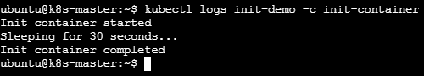

Step 5. Verify the main container
- Run: kubectl logs init-demo -c main-container

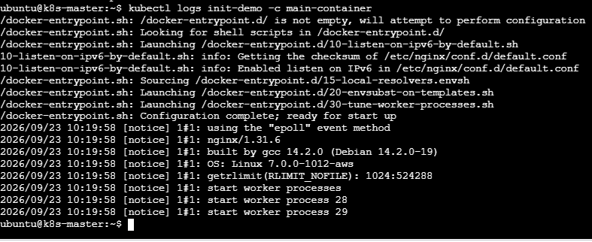
- Because nginx normally doesn't write much to stdout during startup, you may not see much output. That's okay.
- Instead, verify that it is running: kubectl get pod init-demo
- Expected:
NAME | READY | STATUS | RESTARTS | AGE
init-demo | 1/1 | Running | 0 | 1m

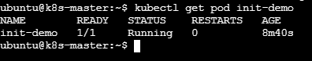

6. Run a Dry Run Command to Generate YAML Task: Use the kubectl run nginx --image=nginx --dry-run=client -o yaml command to generate a Pod YAML definition. Modify the generated YAML to suit specific requirements (e.g., labels or environment variables) and deploy it.

Step 1. Generate the YAML
- kubectl run nginx --image=nginx --dry-run=client -o yaml

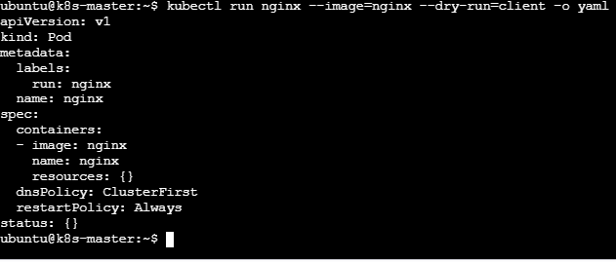

Step 2. Save the generated YAML to a file
- Instead of copying the output manually, use: kubectl run nginx --image=nginx --dry-run=client -o yaml > nginx-pod.yaml
- Now check the file: cat nginx-pod.yaml
- You should see the generated YAML.
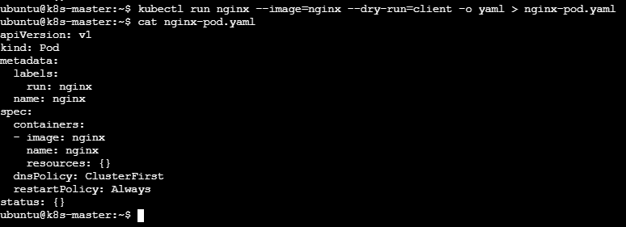

Step 3. Modify the YAML
- Open it: vi nginx-pod.yaml
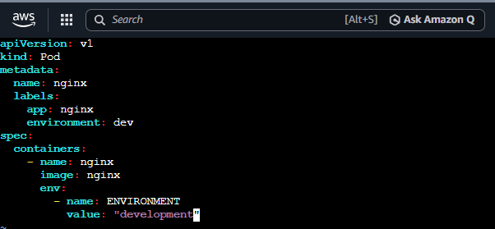

- Here we added:
  - Labels
labels:
app: nginx
environment: dev
- Environment variable
env:
- name: ENVIRONMENT
value: "development"
- Now save exit

Step 4. Deploy the modified YAML
- Run: kubectl apply -f nginx-pod.yaml
- Expected: pod/nginx created

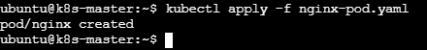

Step 5. Verify the Pod
- kubectl get pod nginx
- You should eventually see:
NAME | READY | STATUS | RESTARTS | AGE
nginx | 1/1 | Running | 0 | 20s

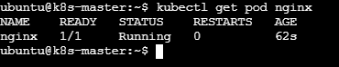
Step 6. Verify the labels
- Run: kubectl get pod nginx --show-labels
- You should see something similar to:
NAME | READY | STATUS | RESTARTS | AGE | LABELS
init-demo | 1/1 | Running | 0 | 30s | app=nginx,environment=dev

This confirms your modified labels were applied.
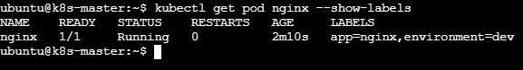

Step 7. Verify the environment variable
- Run: kubectl exec nginx -- printenv ENVIRONMENT
- Expected: development
- This confirms the environment variable was successfully added.
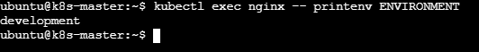

Step 8. View the complete YAML
- Check what Kubernetes actually created: kubectl get pod nginx -o yaml
- You should find:
labels:
app: nginx
environment: dev
and:
env:
- name: ENVIRONMENT
value: development
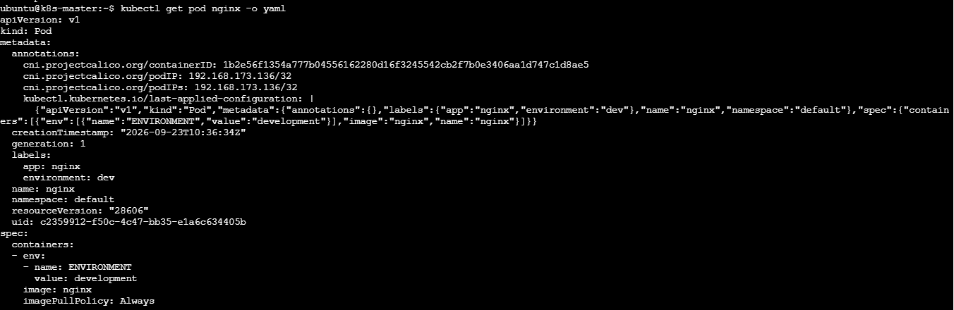

7. Use kubectl apply vs kubectl create Task: Create a YAML file to define a Pod. First, deploy it using kubectl create -f <file_name>.yml and then modify the YAML (e.g., change the image version). Use kubectl apply to redeploy and verify the difference between both commands.

Step 1. Create the YAML file
- Create a file: vi nginx-create-apply.yml
- Save and exit.
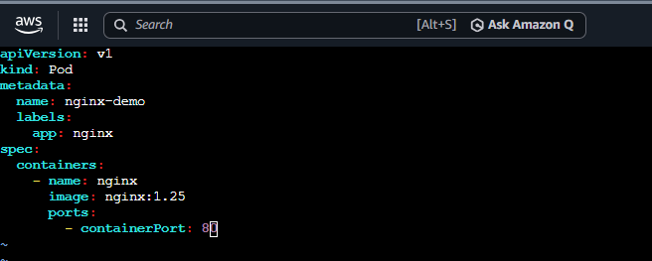

Step 2. Check the YAML
- cat nginx-create-apply.yml
- You should see: image: nginx:1.25

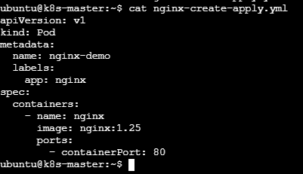

Step 3. Deploy using kubectl create
- Run: kubectl create -f nginx-create-apply.yml
- Expected: pod/nginx-demo created
- Check the Pod: kubectl get pod nginx-demo
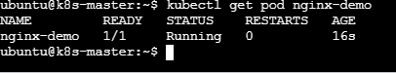

- Check the image: kubectl describe pod nginx-demo | grep -i image
- You should see:
Image: nginx:1.25

Step 4. Now modify the YAML
- This is the important part.
- Open the YAML: vi nginx-create-apply.yml
- Change: image: nginx:1.25
- to: image: nginx:1.27
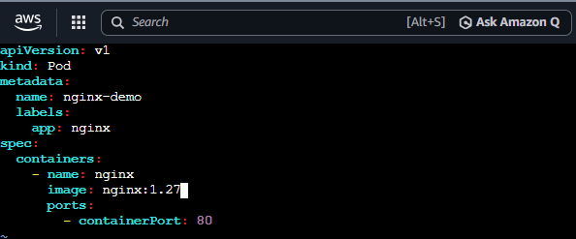
- Save and exit.

Step 5. Try kubectl create again
- Now run: kubectl create -f nginx-create-apply.yml
- You will get an error similar to: Error from server (AlreadyExists): pods "nginx-demo" already exists
- Why? Because create means: Create a new resource.
- The Pod already exists, so Kubernetes won't create another Pod with the same name.
- Therefore:create + existing Pod = ERROR
Step 6. Now use kubectl apply
- Run: kubectl apply -f nginx-create-apply.yml
- You should see: pod/nginx-demo configured
- This is the important difference.
- apply means: Create the resource if it doesn't exist, or update it according to the YAML if it already exists.

Step 7. Verify the image
- Run: kubectl describe pod nginx-demo | grep -i image
- You should now see: Image: nginx:1.27
- You can also run: kubectl get pod nginx-demo -o jsonpath='{.spec.containers[0].image}'
- Expected: nginx:1.27
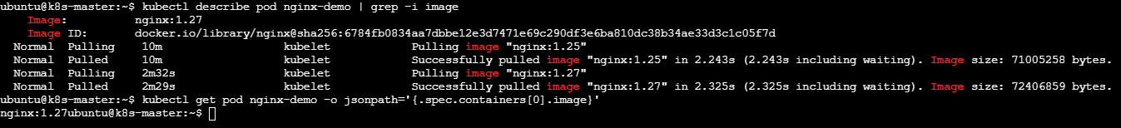

8. Edit an Existing Pod Configuration Task: Use kubectl edit pod <pod_name> to modify the running Pod's environment variables or image. After making the changes, verify if they took effect by checking the container logs or environment variables using kubectl exec.

Step 1. Create a test Pod
- kubectl run edit-demo --image=nginx --env="APP_ENV=production"
- You should see: pod/edit-demo created
- Check it: kubectl get pod edit-demo
- Expected:
NAME | READY | STATUS | RESTARTS | AGE
edit-demo | 1/1 | Running | 0 | …

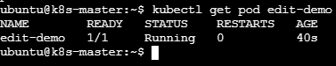

Step 2. Check the current environment variable
- Run: kubectl exec edit-demo -- printenv APP_ENV
- Expected: production
- So currently: APP_ENV=production
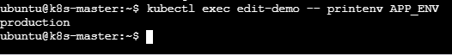

Step 3. Edit the running Pod
- Now run: kubectl edit pod edit-demo
- Your editor will open with the Pod's YAML.
- Find: Image : nginx
- Change it to: Image : nginx 1.27
- Save and exit.
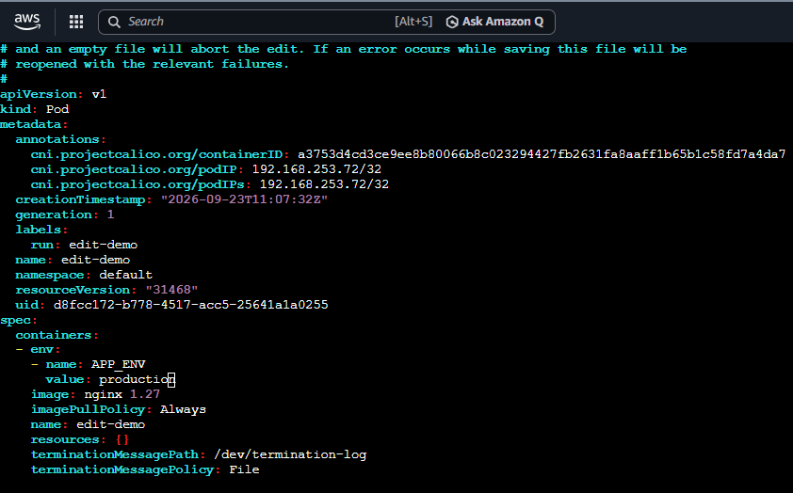

Step 4. Check whether the change was accepted
- After saving, Kubernetes will either accept the change or give you an error.
- If you see: pod/edit-demo edited
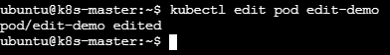
- then check:
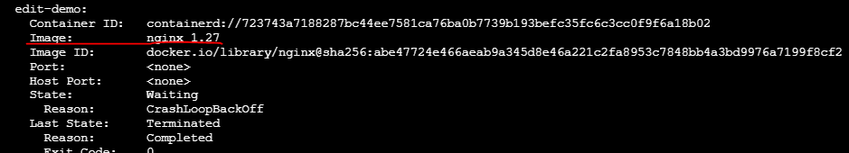
- You want: Nginx 1.27

9. Expose a Pod Using a Service Task: Create a YAML file to expose your firstpod using a Service (ClusterIP). Ensure that your service is exposing the Pod on port 80 and verify it using kubectl get svc.

Step 1. First check that firstpod exists
- On your Kubernetes master/control-plane: kubectl get pod firstpod
- You should see:
NAME | READY | STATUS | RESTARTS | AGE
firstpod | 1/1 | Running | 0 | …

- If your Pod has a different name, use that name instead.
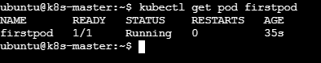

Step 2. Check the Pod's labels
- Run: kubectl get pod firstpod --show-labels
- You might see:
NAME | READY | STATUS | RESTARTS | AGE | LABELS
firstpod | 1/1 | Running | 0 | 1m | run=firstpod

- The label is important because the Service uses a selector to find the Pod.
- In this example:
selector: run: firstpod
must match: run=firstpod
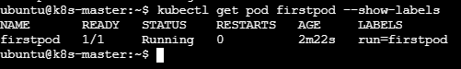

Step 3. Create the Service YAML
- On Kubernetes master
- Create a file: vi firstpod-service.yaml
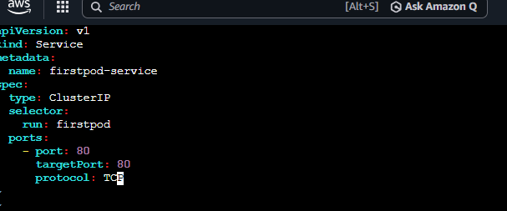
- Save and exit.

Step 4. Create the Service
- Run: kubectl apply -f firstpod-service.yaml
- Expected: service/firstpod-service created
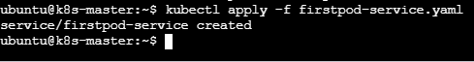

Step 5. Verify the Service
- kubectl get svc
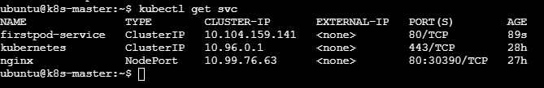

Step 6. Check the Service in more detail
- Run: kubectl describe svc firstpod-service
- Look for:
Type: ClusterIP
Port: 80/TCP
TargetPort: 80/TCP
Endpoints: <Pod-IP>:80
- For example: Endpoints: 10.244.1.5:80
- The Endpoints line is very important.
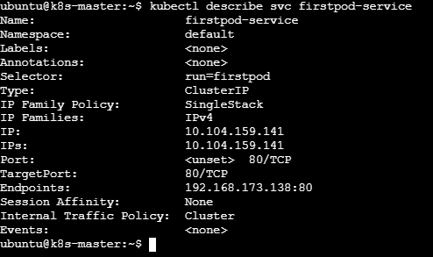
- If you see an endpoint, the Service has successfully found your Pod.

Step 7. Verify the Service selector
- Run: kubectl get pod firstpod --show-labels
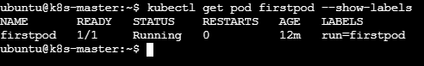
- Suppose you get: run=firstpod
- Then: kubectl get svc firstpod-service -o yaml
- should contain:
selector:
run: firstpod
- They must match.
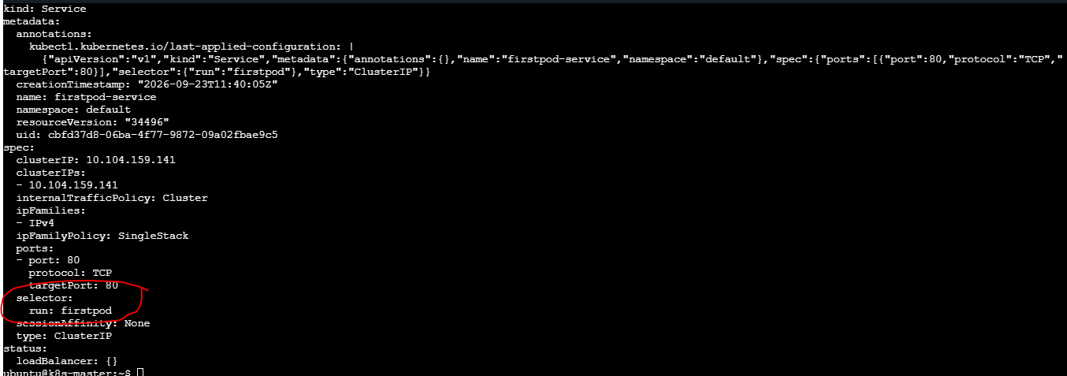

10. Pod with Resource Limits and Requests Task: Add resource requests and limits to the containers in your YAML file. Specify CPU and memory requests/limits for both containers and deploy the Pod. Use kubectl describe pod to verify if the resource configurations are correctly applied.

Step 1: Create the YAML file
- Run on the Kubernetes master:
- vi resource-pod.yaml
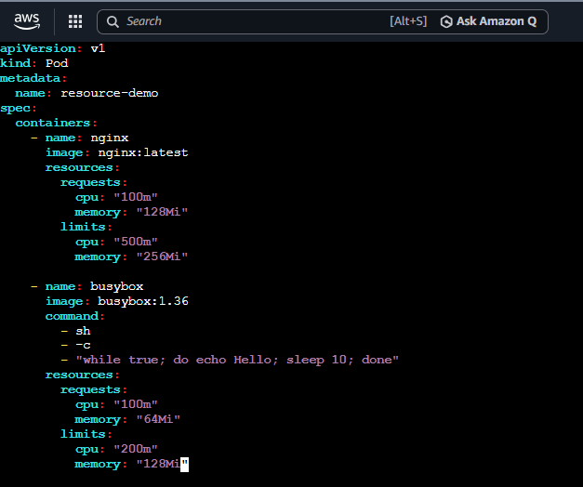
- Save and exit.

Step 2 — Deploy the Pod
- Still on the Kubernetes master: kubectl apply -f resource-pod.yaml
- Expected: pod/resource-demo created
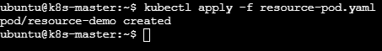
Step 3 — Check the Pod
- kubectl get pod resource-demo
- Expected:
NAME | READY | STATUS | RESTARTS | AGE
resource-demo | 2/2 | Running | 0 | …

- 2/2 means both containers are running.
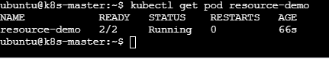

Step 4 — Verify Resource Requests and Limits
- Run: kubectl describe pod resource-demo
- Look for the Containers section.
- For nginx, you should see something similar to:
Limits:
cpu: 500m
memory: 256Mi
Requests:
cpu: 100m
memory: 128Mi
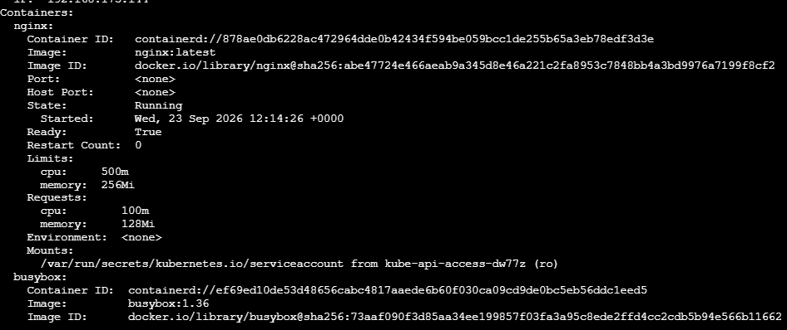
- For busybox:
Limits:
cpu: 200m
memory: 128Mi
Requests:
cpu: 100m
memory: 64Mi
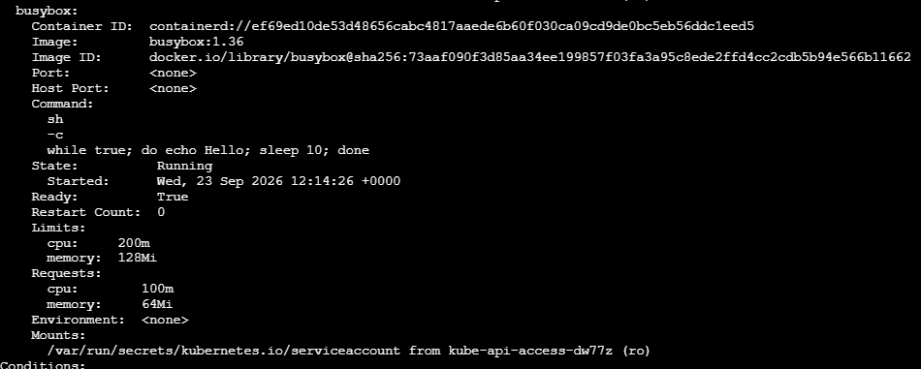

Step 5 — Easier verification
- You can also run: kubectl get pod resource-demo -o yaml
- Then search for: resources:
- You will see the configured requests and limits.
